2021 TOP 5 Low-Budget Beach Destinations

As the global situation is slowly improving, there are high chances that this summer, holidays will actually happen. I know that many of you crave escaping to a sunny place, on a sandy beach, sipping on cocktails.

There is something special about beach holidays, right?

The whole disconnection feeling, chilling under the sun all day, taking long evening barefoot walks on the sand, listening to the waves crashing, watching the sunset, and so on…

Even if travel seems a bit more expensive these days due to PCR testing requirements and other added expenses, low-budget travel is still possible.

We found 5 beach destinations that you could travel to this summer from the UK, without breaking the bank!

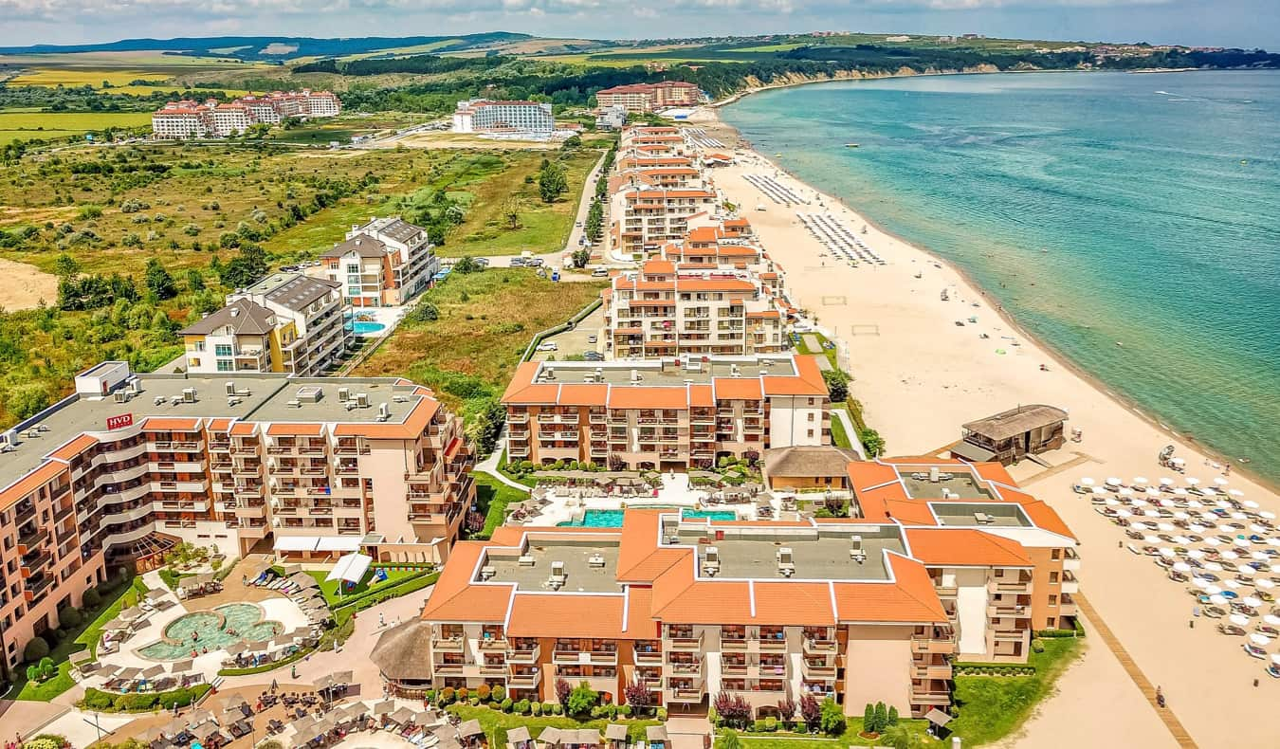1. Sunny Beach, Bulgaria

A recent study reveals that prices in

the Black Sea Resort of Sunny Beach

are at least a third cheaper than most

places in Europe, especially for

all-inclusive hotels.

The local prices dropped by 10.7%

since 2018, visitors can purchase a bottle of local lager for just £0.70, while a two-course lunch for two people (without drinks) costs £8.42.

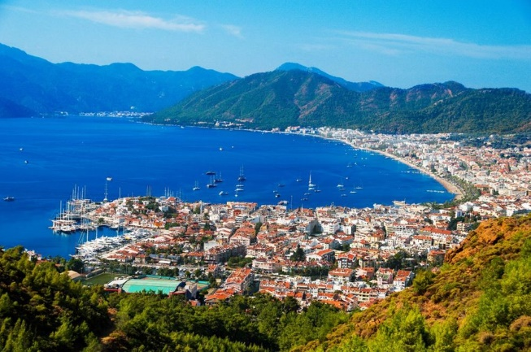

2. Marmaris, Turkey

Marmaris is well known for its white, sandy

beaches like Icmeler Beach, as well as its

beautiful marina. If you stay away from the main strip of the Marmaris Marina and head further onto the alleys, you will find some great bargains, with a pint of local lager starting from £1.40 and a three-course dinner for two from as little as £20.

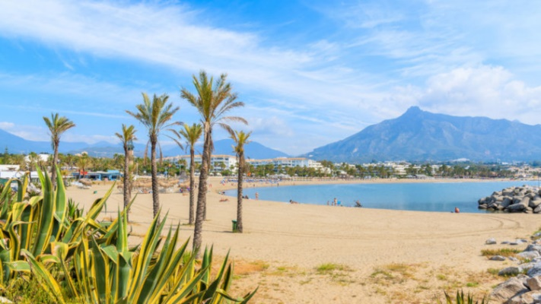3. Costa del Sol, Spain

Spain has always been a hit for brits,

and places like Torremolinos in Costa

del Sol offer a wide range of great deals

for couples and families. If you find

yourself wondering around the

beautiful coastline and arrive in Marbella, if you are not looking to spend much, stick to only walking around this place, as it is on the pricey side of the coast.

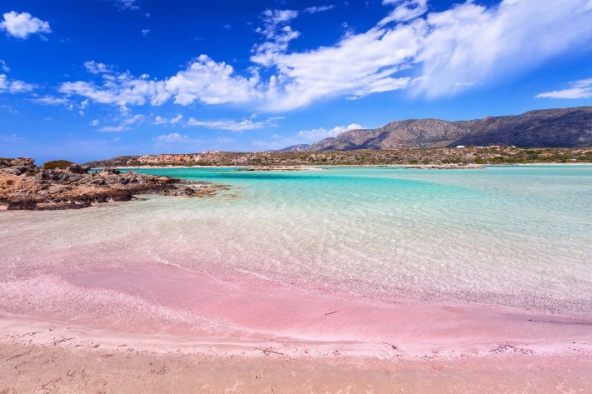4. Crete, Greece

We all remember the holiday to Malia

from *The Inbetweeners*, right?

Well, if you want to visit this

beautiful island, you can do it

while still getting good value for your

money, and you do not have to be

a nightlife person necessarily, as the island is so big, there are quieter areas, and a lot of those areas are catered for families. If you don’t stay in an all-inclusive hotel, head to places where they sell street food to get yourself some cheap, but absolutely delicious foods.

5. Malta

Who doesn’t like a place where one

of the official languages is English,

where is extremely hot, gorgeous

scenery and affordable?

Malta is definitely an excellent choice,

and is more than likely that this country is

going to be on the UK’s green list, making traveling possible as early as the beginning of June.

Be aware that there are not many sandy beaches in Malta, most of them have

stones and rocks, however you can visit the surreal Blue Lagoon to make it up for it. Also, if you want to stay in a modern-looking hotel, these could be quite expensive. Most hotels in Malta are pretty outdated, but their cleanliness cannot be doubt.